3D Nursing VR Simulator
how to test the project
the project can be tested in one of the following 2 options:
- using unity project source
- using Android Application

Option 1: testing using source code:
- Clone the project from github
- use unity 2021.1.26f1 or newer version
- open the project from the sub-folder: “\Source\Nursing-Sim”
- open the main scene at “Assets\Scenes\VR_MenuLobby.unity”
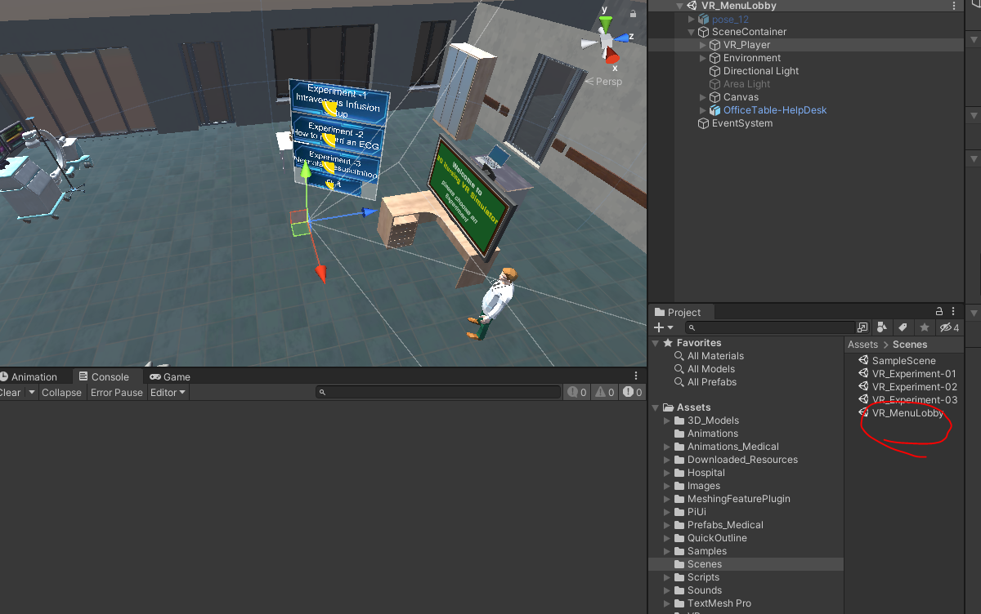
- run the demo
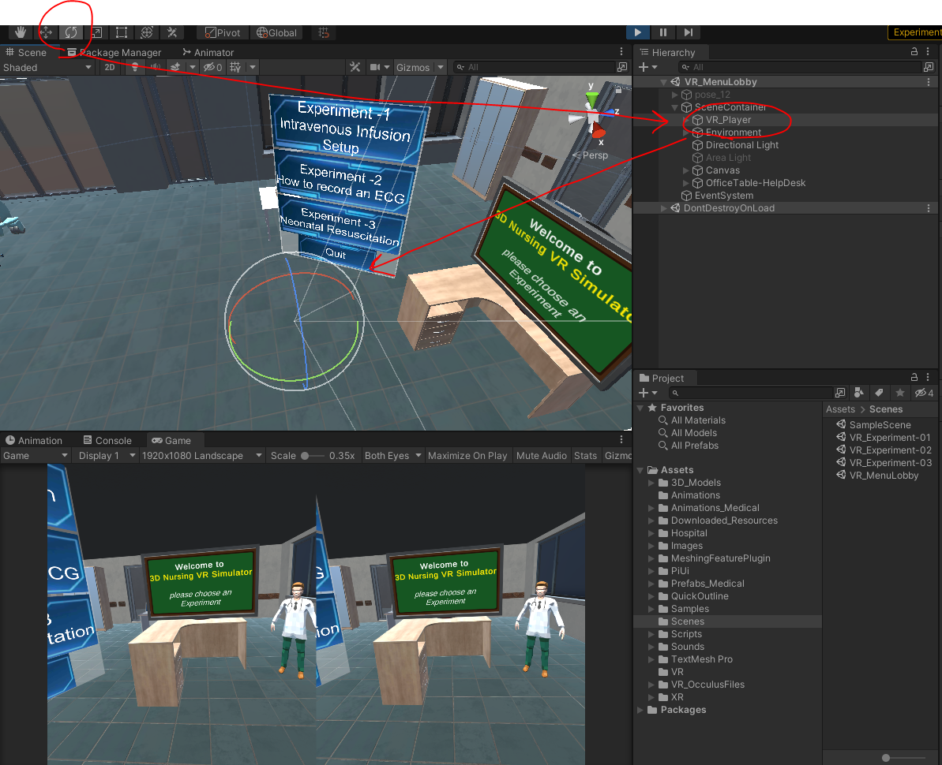
- to simulator the headset rotation inside unity editor you can use the rotate tool for the object VR-Player

Option 2: testing using Android APK:
- Install the application APK from path : “Executable-Android APK\N20.apk”
- open the application NursingSimulator2 using android mobile
- put the mobile device inside a mobile headset
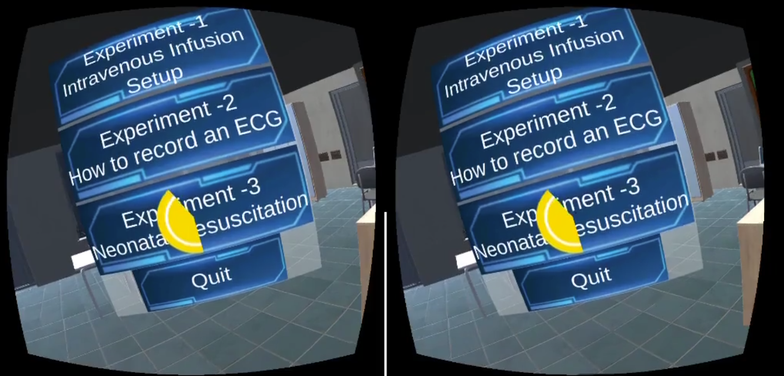
- the application is gaze based (ie. it uses eye direction to select action), to select any action keep looking at it for about 2 seconds till the yellow circular progress completes

Mobile Controls
The mobile application is gaze based, so it depends on head rotation and eye looking duration.
- camera rotation: is done by rotating head
- Movement (Walking): it’s teleportation based. So, you can move by looking 2 seconds into one of the green boxes on the ground. When the yellow circle completes the teleportation is executed and position changes.
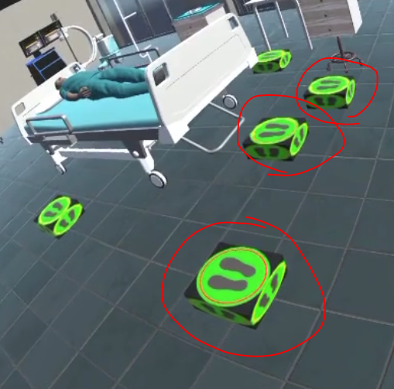
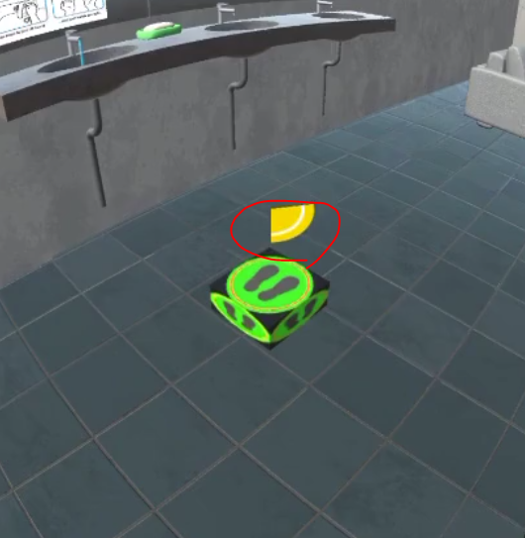

3-Using items and UI buttons: if item is usable, then by looking at it a blue panel appears, and if looking time is 2 seconds, then a yellow circle is completed and the item is used
